Module 3 — Economic Optimum in Farming
More input does not always mean more profit — it is the point where the cost of one additional unit of input is exactly equal to its benefit.

1. Learning Objectives
- Understand the concept of Economic Optimum through simple examples.
- Understand why and how using more fertiliser or inputs does not always give more profit.
- Learn how to find your own economic optimum for your own farm.

2. Introduction
The economic optimum is the point at which the additional benefit obtained from using one more unit of an input (e.g. fertiliser, seed, water) equals the additional cost of that input. Beyond this point, every additional rupee spent on the input does not return that much value — so even if output keeps rising a little, profit starts to fall.
The most important lesson is this: more inputs does not automatically mean more profit. The maximum profit will not necessarily be found where the maximum output is obtained — the question is not “where is the maximum output obtained?” but “where is the maximum profit obtained?”.

3.1 What is economic optimum?
Economic optimum is that proper quantity of an agricultural input at which the best economic balance is struck between the additional cost incurred on it and the additional benefit obtained from it.
Put simply — increasing fertiliser or seed may raise output at first. But after a certain stage, cost increases while the rise in output becomes smaller; because of this, profit begins to fall. That is why, when deciding the quantity of an input in farming, it is necessary to consider cost and profit along with output.
Economic Optimum
Economic optimum = the quantity of input that gives maximum profit, not maximum output
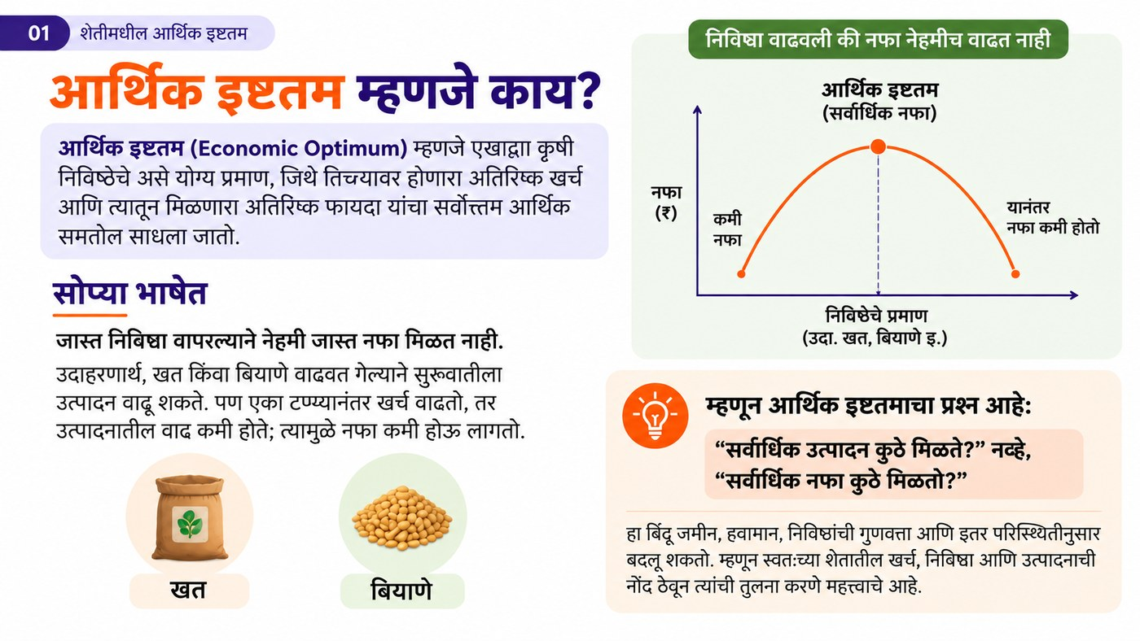
Figure 3.1 — Profit does not always rise when input is increased (graph of economic optimum)

3.2 Understanding through examples
Let us look at the example of nitrogen fertiliser in rice and wheat. On comparing different nitrogen levels — looking at both output and profit — it was found that for rice without farmyard manure the economic optimum nitrogen is about 125 kg/hectare (approximately 2.2 urea bags/acre), while with farmyard manure it drops to 100 kg/hectare (approximately 1.75 bags/acre). For wheat this level is about 125 kg/hectare.
A simple way to understand this is the example of a cow. Suppose a cow gives 10 litres of milk a day when given 20 kg of fodder. If the fodder is increased to 25 kg, she can give 15 litres of milk — this is her economic optimum. But after that, even if the owner gives her 26 kg, 30 kg or more fodder, the cow will still give only 15 litres.
If the owner wants more milk, then giving more fodder beyond this point will not help — instead the remedy is to buy another cow, or to get a good-breed cow that gives more milk. The same logic applies to farming: beyond the economic optimum, instead of increasing fertiliser, choosing a variety that gives higher yields is often more profitable.

Figure 3.2 — The cow example: increasing fodder does not always increase milk
Table 3.1 — Crop-wise economic optimum nitrogen level (example)
Crop | Economic optimum nitrogen | Equivalent urea*
Rice – without farmyard manure | 125 kg N/hectare | ~2.2 bags/acre
Rice – with farmyard manure | 100 kg N/hectare | ~1.75 bags/acre
Wheat – without/with farmyard manure | 125 kg N/hectare | ~2.2 bags/acre

3.3 How to find your own economic optimum?
The economic optimum in farming is far more complex and individual than any table — it depends on many things such as soil structure, the quality of inputs used, and weather conditions. A published figure can be a useful starting reference, but it will not necessarily be the farmer’s own true figure.
If a farmer wants to know the true economic optimum for his crops, he must keep a record of the farming costs for every crop in every season. For example, when a farmer recorded the quantity of fertiliser and the output for at least 3 seasons, he got the following results:
Table 3.2 — A farmer’s own records (3 seasons)
Fertiliser used | Crop output | Economic result
1 bag (50 kg) | 8.0 quintals | Low profit
1.5 bags (75 kg) | 8.5 quintals | Maximum profit ✅
2 bags (100 kg) | 8.6 quintals | Profit falls

Although a little more output is obtained from 2 bags, the cost of the additional fertiliser is more than the value of the additional output. So, for this crop on this farmer’s farm, 1.5 bags (75 kg) of fertiliser is the economic optimum.
That is, the method of finding the economic optimum is: Record → Compare → Find the optimum → Increase profit. Without recording the cost of farming, no farmer can ever find his own true economic optimum — he only depends on guesswork, and if the guess goes wrong in either direction there is a loss: with too little fertiliser, output that could have been had cheaply is lost, and with too much fertiliser, money is wasted that would never have been recovered.

Figure 3.3 — The four steps to find your farm’s economic optimum

Key Concepts
- Economic Optimum: the quantity of input that gives maximum profit (not maximum output).
- Marginal cost and marginal benefit: the cost of using one additional unit of input and the additional benefit obtained from it.
- Output versus profit: more output does not always mean more profit.

Key Takeaways
- Using more fertiliser, seed or water can raise output, but profit will not necessarily rise.
- The economic optimum is different for every farm — it depends on the soil, the weather and the quality of inputs.
- Published general figures are only a starting reference — your own records are necessary to find your own economic optimum.
- Without comparing the records of at least 2-3 seasons, your own true economic optimum cannot be found.

Review Questions
- What is economic optimum? Explain on the basis of the cow example.
- Why can profit fall even after using more fertiliser?
- What are the four steps to find the economic optimum for your own farm?

Module Summary
Economic optimum is the point at which the additional cost on an input and the additional benefit from it become equal — maximum profit is obtained at this very point. From the rice-wheat and cow examples we saw that even if output rises with more inputs, profit can fall. Since every farm’s economic optimum is different, to find it a farmer must keep his own records for at least 2-3 seasons and compare them.

